Name:Tharun Bhukya

700#:700747504

Github Link: <https://github.com/tharunbhukya/CS5720-ICP5>

Video Link: https://drive.google.com/file/d/1JKWt64qjr64jOnthlSY6za4eWEXsKoAX/view?usp=sharing

1)

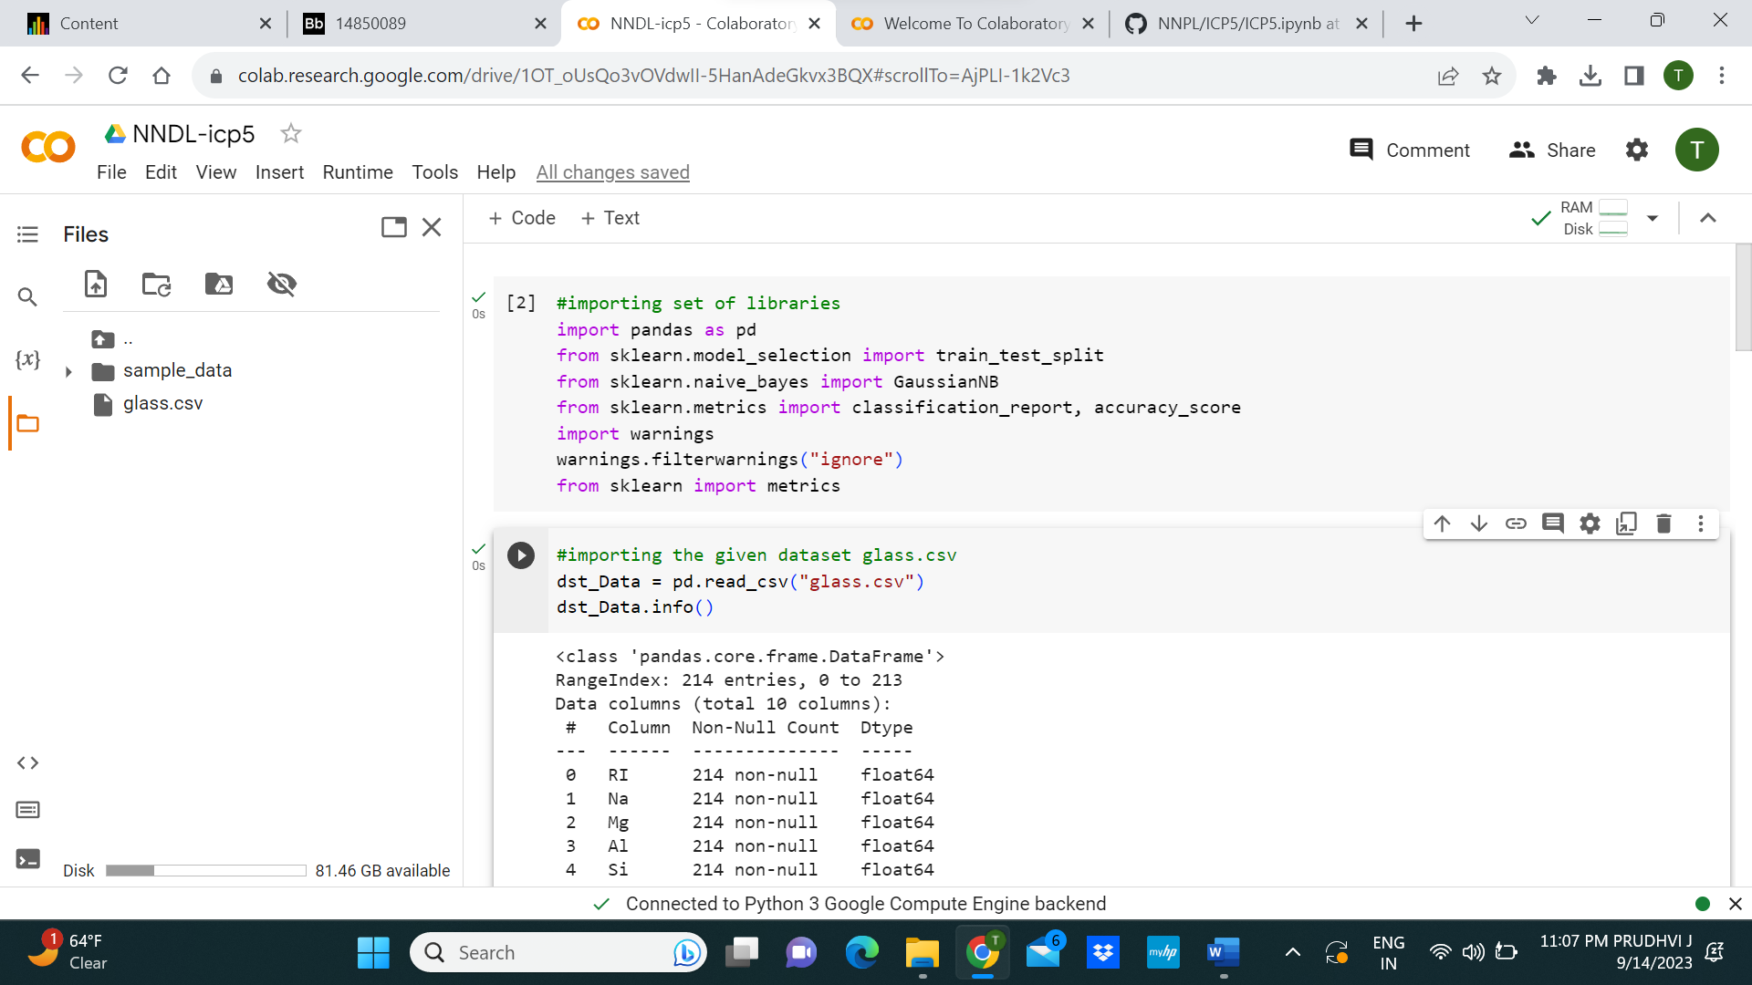

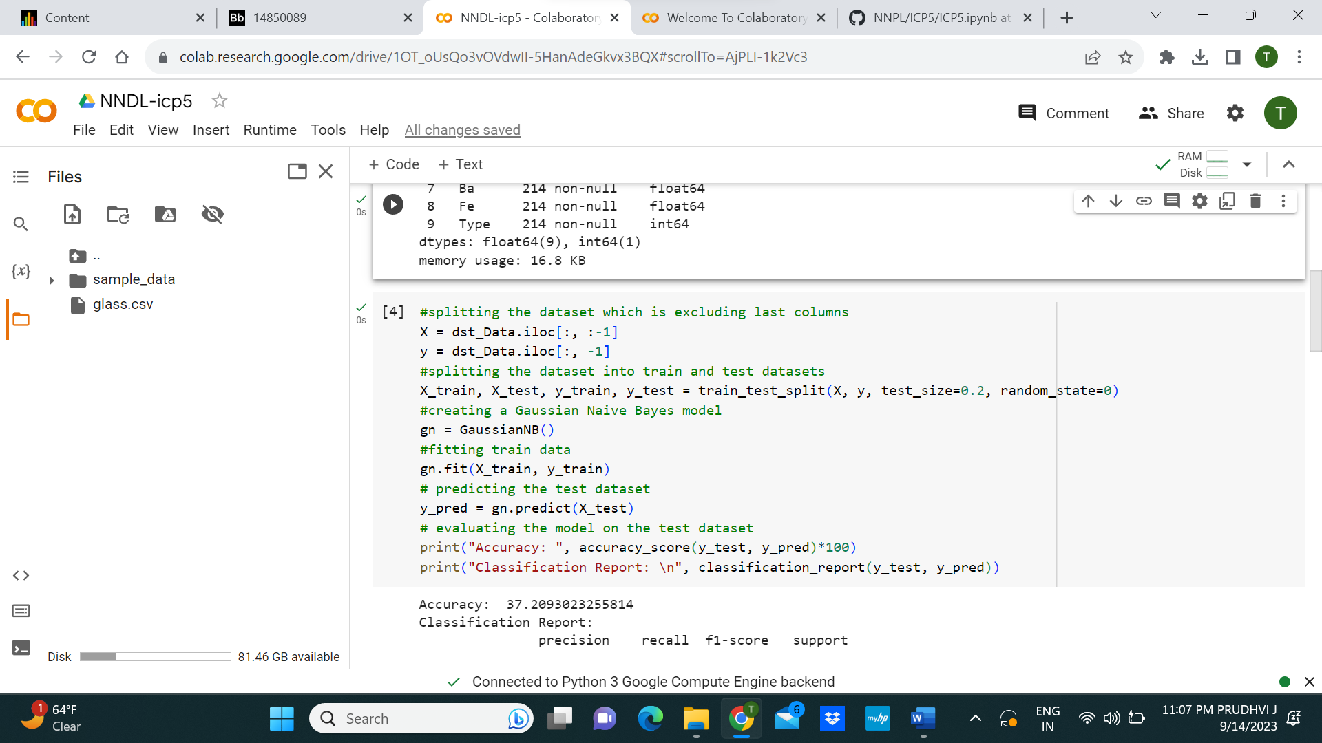

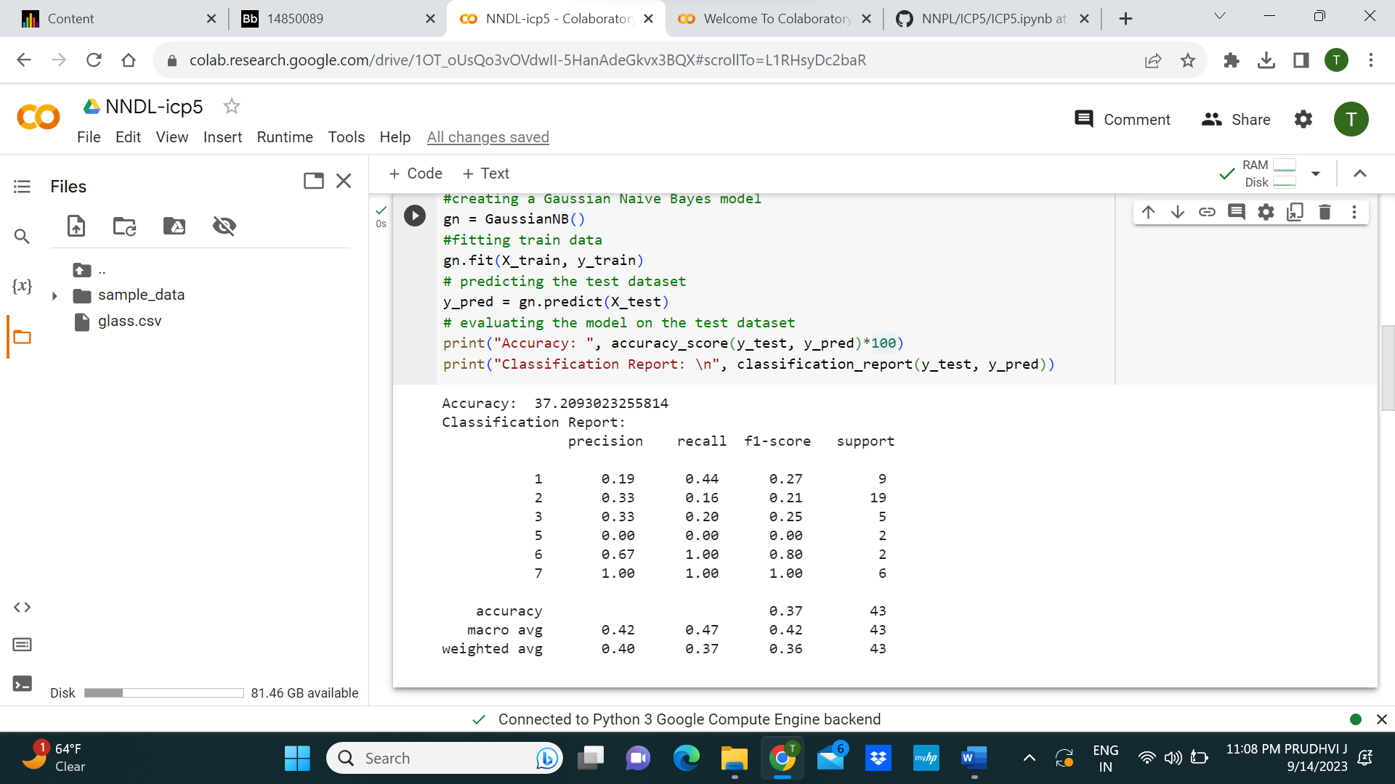

2)

